**Variable:** A symbol which takes different numeric values throughout a set of mathematical operations is called a variable. Variables are usually denoted by letters of the alphabet, such as , , , , , , , , etc.

**Constant:** A symbol which retains the same numerical value throughout a set of mathematical operations is called a constant. Constants (other than numerical constants like , , , , etc. ) are usually denoted by the earlier letters of the alphabet, such as , , , , etc.

**Coefficient:** A coefficient is a number which is used to multiply a variable. For example, 5y means 5 times y, and "y" is a variable, so 5 is a coefficient.

To understand clearly, we may observe the following figure, where 4 is coefficient, x is variable, - is operator and 7,5 are constants.

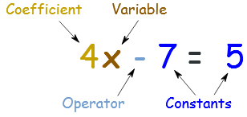

**Parameter:** A parameter is a symbol which is used to identify or classify the behavior of a mathematical object. For example,, here , and  are parameters that determine the behavior of the function . For each value of the parameters, we get different functions which are parabolas.

**Co-ordination system:**  A coordinate system is a method for identifying the location of a point on the [plane](http://www.mathopenref.com/plane.html) using two numbers called an ordered pair of numbers or coordinates. The first element of the ordered pair represents the distance of that point on x-axis called abscissa and second element on y-axis called ordinate. This abscissa and ordinate makes coordinates of that point. The method of describing the location of points in this way was proposed by the French mathematician René Descartes (1596 - 1650). He proposed further that curves and lines could be described by equations using this technique. In honor of his work, the coordinates of a point are often referred to as its Cartesian coordinates and the coordinate plane as the Cartesian Coordinate Plane.

**Coordinates Systems in Two Dimensions:** There are two systems in two dimensions such as:

1. **Cartesian/Rectangular Coordinates System:**

In this system, to locate the position of a point on the plane, there are needed two perpendicular intersecting straight lines.These two straight lines are named as rectangular axes and intersecting point as the origin denotes by the symbol **O**. In Cartesian coordinate system position of a point is measured by the distance on both axes. First one is on x-axis called abscissa denoted by the symbol ***x*** and second one is on y-axis called ordinate denoted by the symbol *y.* We express the coordinate of a point **P** in Cartesian plane by the ordered pair *P(x,y)*.

**( + , - )**

**( - , - )**

***x***

**y**

Origin

**O**

**X’**

**X**

**Y**

**Y’**

**( + , + )**

**( - , + )**

P (*x,y*)

The horizontal line XOX’ is called x-axis and the vertical line YOY’ is called y-axis. Both axes divide the whole plane into four parts called Quadrants. Four Quadrants XOY, X’OY, X’OY’ and XOY’ are called anti-clock-wisely 1st, 2nd, 3rd and 4th quadrant respectively. The coordinate of the origin is **O**(0,0) because all distances measured considering origin as starting point.

1. **Polar coordinates System:**

In this system for locating the point **P** in a plane we take a fixed point **O** called the pole and a fixed straight line **OX** called the initial line. Joining line of the points P and O is called radius vector and length of radius vector **OP** = r and the positive angle  is called vectorial angle.

***r***

Origin

**O**

**X’**

**X**

**Y**

**Y’**

**P(r,θ)**

**θ**

It is sometimes convenient to locate the position of a point **P** in terms of its distances from a fixed point and its direction from a fixed line through this point. The coordinates of points in this system are called Polar coordinates. The polar coordinates of the point P are expressed as . In this system the same point has an infinite number of representations and it is the demerits of polar coordinate system to Cartesian system. For example, the point P has the coordinates etc.

**Relation between Cartesian and Polar Coordinates Systems:**

Suppose that the coordinates of the point P in Cartesian system is and in Polar system is . We would like to establish the relation between two coordinates systems. From the triangle with the help of trigonometry we can find the relation between the Cartesian system & the polar system.

x

***r***

**O**

**X’**

**X**

**Y**

**Y’**

**P(r,θ)**

**θ**

**P(x,y)**

y

From the pictorial triangle

We get,

and

Again,

Applying Pythagorean Theorem from geometry we have a relation,

and .

Therefore the relations are:



and

**Problem-01:** Determine the polar coordinates of the point.

**Solution:** We have .

Therefore  and 

We know that,



And



Therefore, the polar form of the given point is or.

**Problem-02:** Determine the Cartesian coordinates of the point.

**Solution:** We have .

Therefore  and 

We know that,



And



Therefore the Cartesian form of the given point is .

**H.W:**

**1. Convert the following points to the polar form:**

**i) ii) iii) iv) **

**v) vi) vii) **

**2. Convert the following points to the Cartesian form:**

**i) ii) iii) iv)v) **

**vi) vii)  viii)  ix)  x) **

**Problem-03:** Transform the equation  to Polar equation.

**Solution:**

Given Cartesian Equation is, .

We have

and

Now replacing x and y from the above equation by its values given equation reduces to the following form









**(As desired)**

**Problem-04:** If x, y be related by means of the equation, find the corresponding relation between and .

**Solution:** Given Cartesian Equation is, .

We have

and

Putting  and  the above relation is transformed into the following form







**(As desired)**

**H.W:**

**Convert the followings to the polar form:**

1. 
2. 
3. 
4. 
5. 
6. 

**Problem-05:** Transform the equation to Cartesian equation.

**Solution:** Given Polar Equation is, .

We have

,

Putting, the above relation is transformed into the following form















**(As desired)**

**H.W:**

**Convert the followings to the Cartesian form:**

1. 
2. 
3. 
4. 
5. 
6. 

**Coordinates Systems in Three Dimensions:** There are three systems in three dimensions such as:

* **Cartesian /Rectangular coordinate System(RS):**

In the Cartesian coordinate system in 3D, the point in a space or in three dimensional systems be represented by the symbol where x is the distance on x axis, y is the distance on y axis and z is the distance on z axis of the point.

Figure:

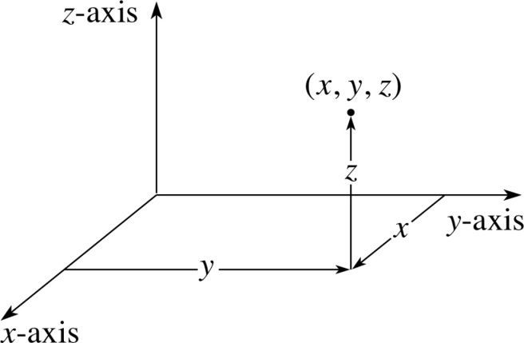

* **Cylindrical coordinate System(CS):**

In the Cylindrical coordinate system in 3D, the point in a space or in three dimensional systems be represented by the symbol $(r,θ,z)$ where r is the distance of the point from origin or length of radial line,  is the angle between radial line and x axis and $z$ is the distance of the point $P$ from the xy plane.

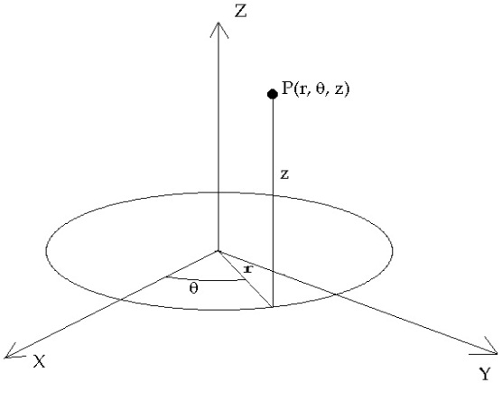

* **Spherical coordinate system(SS):**

In the Spherical coordinate system in 3D, the point in a space or in three dimensional systems be represented by the symbol **(**,θ,**)** where  is the distance of the point from origin or length of radial line,  the angle between radial line and the x axis and  is the angle between radial line and z axis.

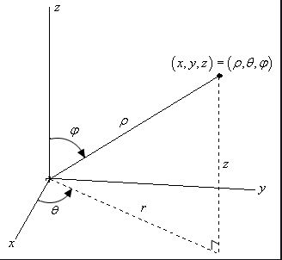

**🞔🞔 Relation between Cartesian and Cylindrical Systems:** Suppose, the coordinates of a point in Cartesian system is  and the cylindrical system is . Then the relations are,

** **

**🞔🞔 Relation between Cartesian and Spherical Systems:** Suppose, the coordinates of a point in Cartesian system is  and the Spherical system is . Then the relations are,

** **

**🞔🞔 Relation between Cylindrical and Spherical Systems:** Suppose, the coordinates of a point in the cylindrical system is and Spherical system is . Then the relations are,

** **

**Restriction:**



**Problem-01:** Convert to Cartesian system.

**Solution:** The given coordinate is in Cylindrical system.



Here, 

We know that,



Now, 





Therefore, the Cartesian coordinates of the given point is.

**H.W:**

Convert the followings cylindrical coordinates to the Cartesian Coordinates system:

**1. **

**2. **

**Problem-02:** Convert  to Cylindrical system.

**Solution:** The given coordinate is in Cartesian or Rectangular system.



Here,

We know that,

** ,**  , 

Now,





And



Therefore, the Cylindrical coordinates of the given point is.

**H.W:**

Convert the followings Cartesian coordinates to the Cylindrical Coordinates system:

1. 
2. 
3. 
4. 
5. 
6. 
7. 

**Problem-03:** Convert to Cartesian Coordinates.

**Solution:** The given coordinate is in Spherical system.



Here, 

We know that,



Now,





And 

Therefore, the Cartesian coordinates of the given point is

**H.W:**

Convert the followings Spherical coordinates to the Cartesian Coordinates system:

1. 
2. 
3. 

**Problem-04:** Convert  to Spherical Coordinates.

**Solution:** The given coordinate is in Cartesian system.



Here, 

We know that,



Now,





And 

Therefore, the Spherical coordinates of the given point is.

**H.W:**

Convert the followings Cartesian coordinates to the Spherical Coordinates system:

1. 
2. 
3. 
4. 
5. 
6. 
7. 

**Problem-06:** Convert  to Spherical Coordinates.

**Solution:** The given coordinate is in Cylindrical system.



Here, 

We know that,



Now,





And 

Therefore, the Spherical coordinates of the given point is.

**H.W:**

Convert the followings Cylindrical coordinates to the Spherical Coordinates system:

1. 
2. 
3. 

**Problem-06:** Convert to Cylindrical system.

**Solution:** The given system is in Spherical system.



Here,

We know that,



Now,





And 

Therefore, the Cylindrical coordinates of the given point is.

**H.W:**

Convert the followings Spherical coordinates to the Cylindrical Coordinates system:

1. 

**Transformation of Equations**

**Problem-01:** Express Cartesian Equation  in Cylindrical Equation.

**Solution:** Given Cartesian Equation is,

we have



Replacing *x* and *y* from the given equation we get desired Cylindrical equation as follows,











**(As desired)**

**Problem-02:** Express Cartesian Equation  in Cylindrical Equation.

**Solution:** Given Cartesian Equation is 

We have,



Replacing *x*, *y* and *z* from the given equation we get desired Cylindrical equation as follows,







**(As desired)**

**H.W:**

Transform the following Cartesian equations into the Cylindrical Equations:

1. 
2. 
3. 
4. 

**Problem-03:** Transform Cartesian Equation  to Spherical Equation.

**Solution:** Given Cartesian Equation is 

We have,



Replacing *x*, *y* and *z* from the given equation we get desired Spherical equation as follows,

















** (As desired)**

**H.W:**

Transform the following Cartesian equations into the Spherical Equations:

1. 
2. 
3. 
4. 
5. 

**Problem-04:** Transform Spherical Equation  to Cylindrical Equation.

**Solution:**

Given Spherical Equation is 

We have,



Replacing  from the given equation we get desired Cylindrical equation as follows,



 



**(As desired)**

**H.W:**

Transform the following Spherical Equations into the Cylindrical Equations:

1. 
2. 
3. 

**Problem-05:** Transform Cylindrical Equation  to Cartesian/Rectangular Equation.

**Solution:** Given Cylindrical Equation is 

We have,



Replacing  from the given equation we get desired Cartesian equation as follows,











[Putting values] **(As desired)**

**H.W:**

Transform the following Cylindrical Equations into the Cartesian/Rectangular Equations:

1. 
2. 

**Problem-06:** Transform Spherical Equation  to Cartesian/Rectangular Equation.

**Solution:** Given Spherical Equation is 

We have,



Replacing  from the given equation we get desired Cartesian/Rectangular equation as follows,















**(As desired)**

**H.W:**

Transform the following Spherical Equations into the Cartesian/Rectangular Equations:

1. 
2. 
3. 
4. 